Hw2. Difference Table 資工三甲 407261128 康智絜

1. f(1.2,1.25) = **1.33530931** 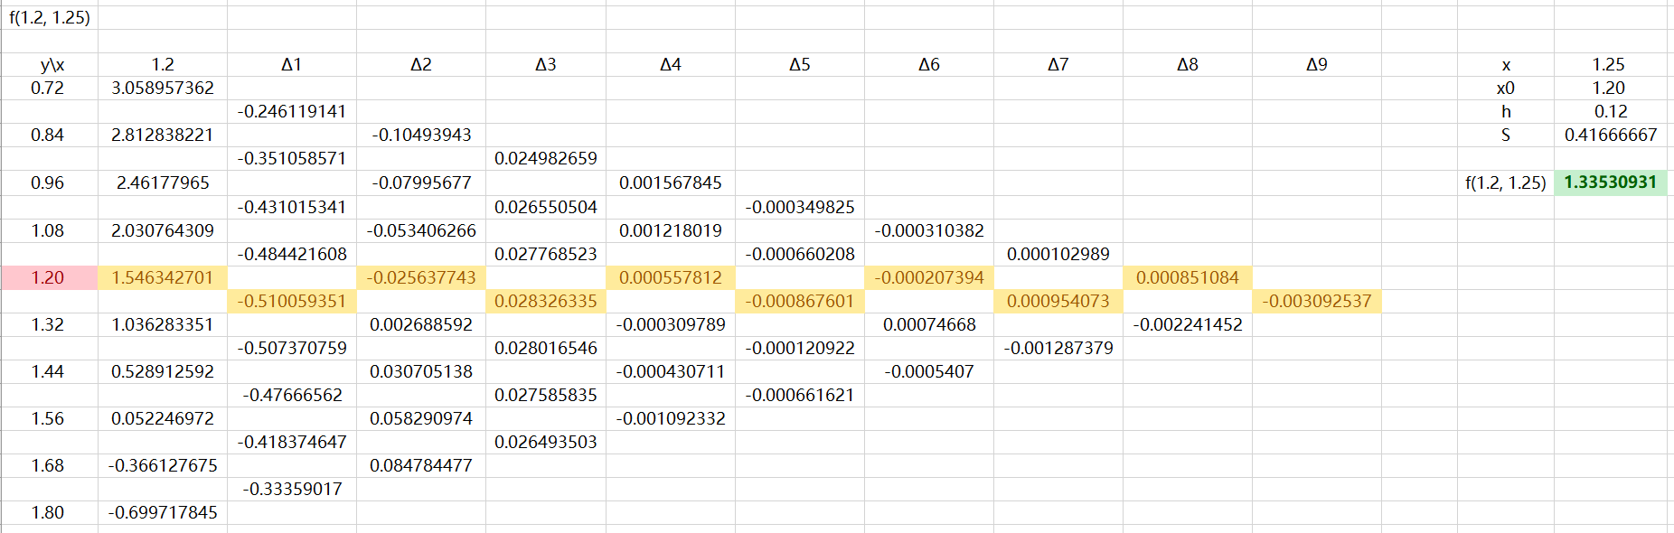
2. f(1.8,1.72) = **-2.080120996**

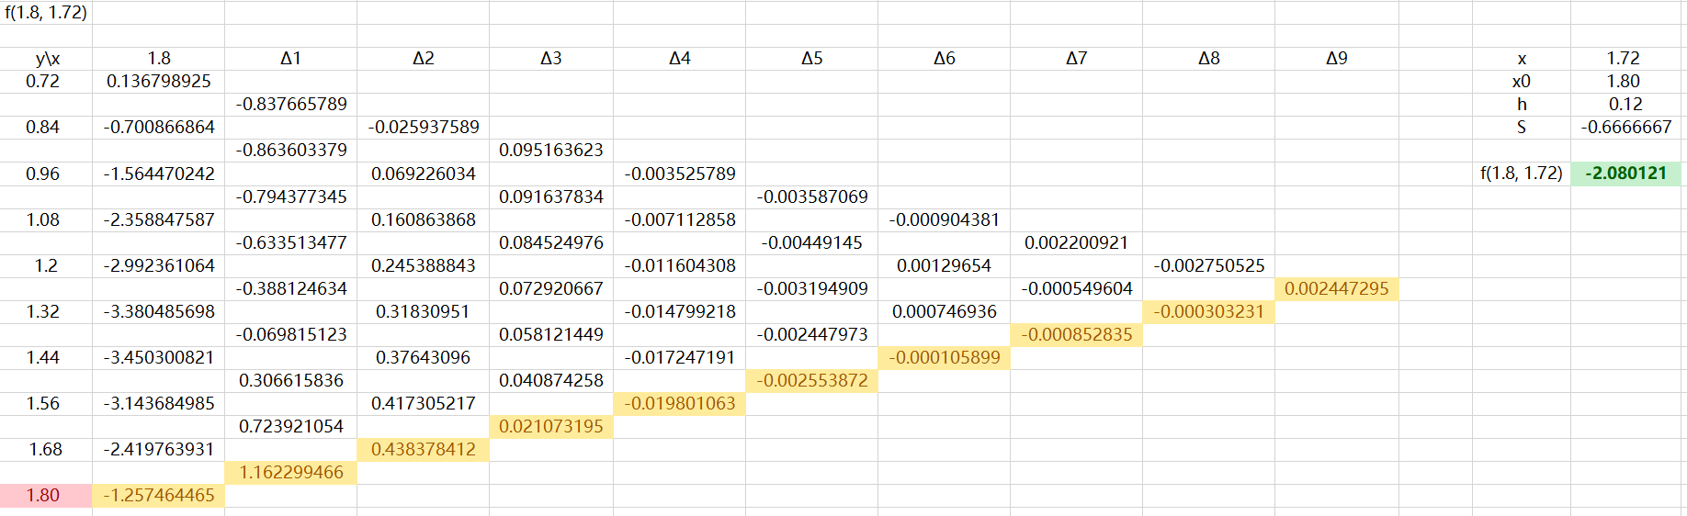

1. f(2.5,1.00) = **-3.138741779**

